Installation Instructions -MacOS
TempicoSoftware – macOS Installation Guide

STEP 1. Unzip the Installer
Double-click the downloaded file to extract its contents into a new folder. Inside, you’ll find three items: the TempicoSoftware application, the installer script (“Install TempicoSoftware.command”), and this guide.
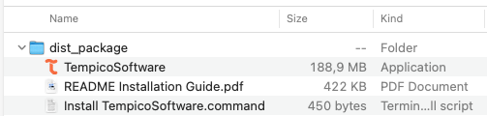
STEP 2. Open Terminal
Press Command (⌘) + Space to open Spotlight Search
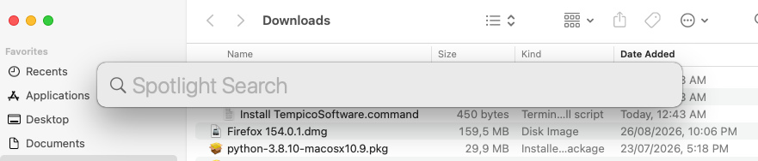
Type “Terminal”
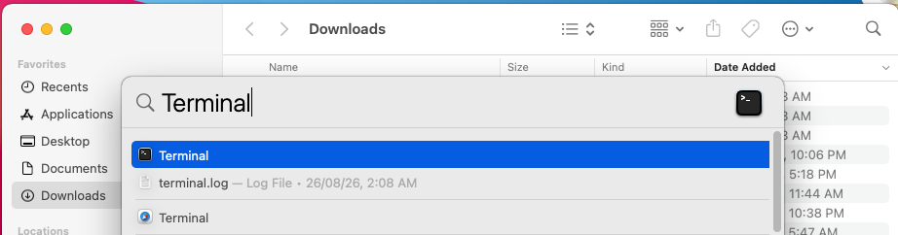

Press Enter. The Terminal window will open.
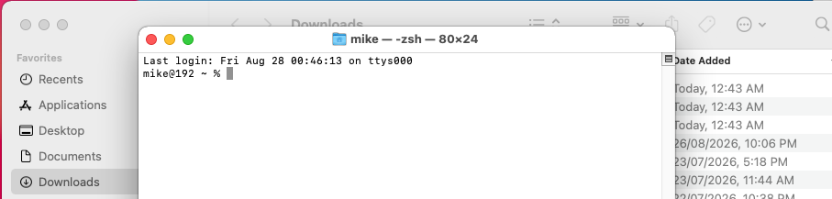

STEP 3. Clear the security flag
Type the following command in Terminal, including tailing space, but do not press Enter yet:
xattr -d com.apple.quarantine
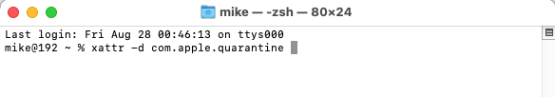
With the command line still selected, drag the “Install TempicoSoftware.command” file from the unzipped folder into the Terminal window, right after the command. This automatically fills in the correct file path — do not type it manually.
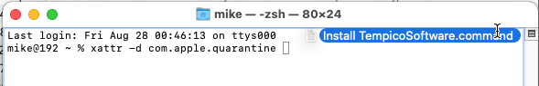
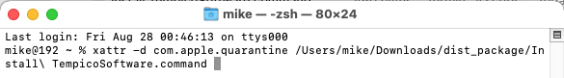
Press Enter to run the command.
Note: On some machines, Terminal may respond with “No such xattr: com.apple.quarantine”. This is not an error — it simply means that particular Mac’s security settings didn’t flag the file with the quarantine attribute in the first place, so there was nothing to remove. It’s safe to continue to the next step regardless.
STEP 4. Run the Installer
Return to the unzipped folder and double-click “Install TempicoSoftware.command”.
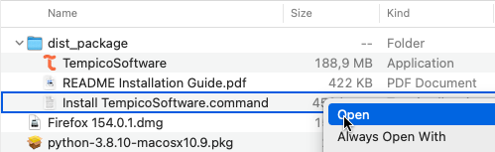
Note: if macOS shows a security warning at this point, go to System Settings → Privacy & Security, scroll to the Security section, and click “Open Anyway” next to the TempicoSoftware entry.
STEP 5. Done
TempicoSoftware will install into the Applications folder and open automatically. The installer file will remove itself once installation is complete, leaving only this guide in the unzipped folder. You can delete the folder at any time — TempicoSoftware is now available from Applications or Spotlight, and will open normally from now on.

